Flower Sale
  - Support the Menands School PTA with a Flower Sale for the Drama Production
$1 per Flower  Order ahead of time by  submitting order form to homeroom  teacher by 16March2022  OR  Order online at:  https://menandsschool.memberhub.com/store/items/679015  Flowers will also be available for sale at the door while supplies last | 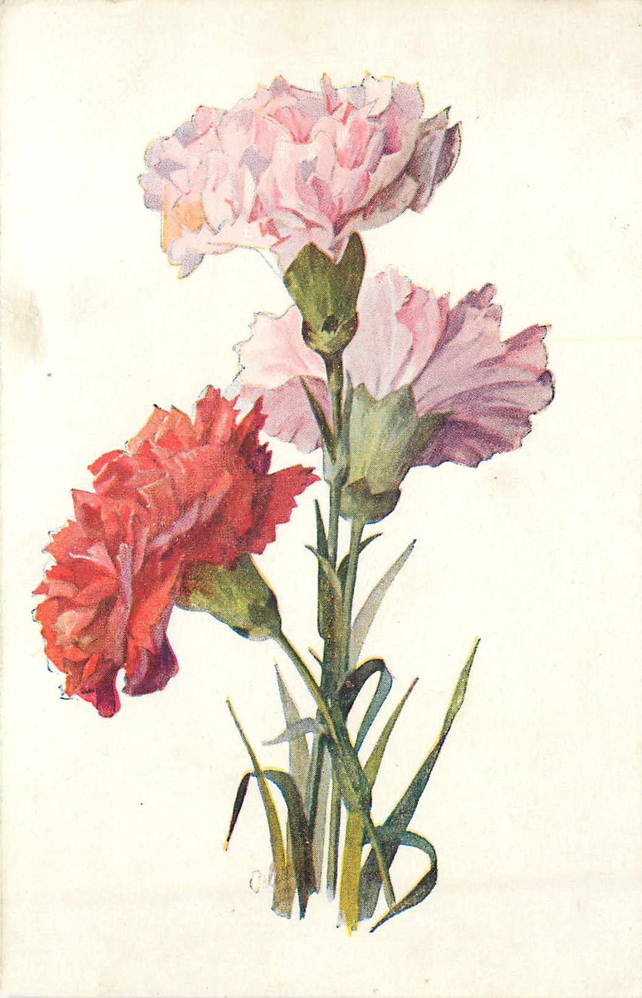

Name of Person Picking up
Which Show (Circle one) | Friday 6pm Saturday 2pm

Student’s name

Number of flowers
Total amount enclosed | $____________ Cash/check (circle one)

