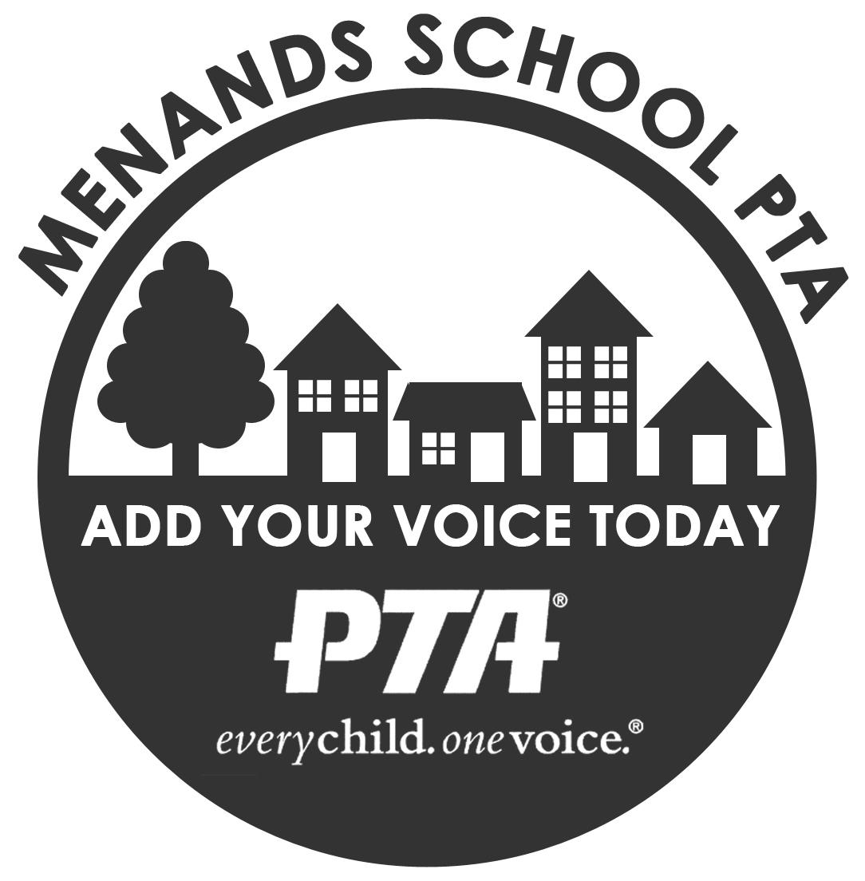
Madalyn Royal, President Menands School PTA
Tammy McNamara, Vice-President 19 Wards Lane
Lindsey Lipari, Treasurer Menands, New York 12204
Jessica Klami , Secretary menandsschoolpta.com

Menands School PTA General Virtual Meeting
April 27, 2021
6:30 PM

Meeting Agenda

Welcome and Introductions:

Reading and Approval of Minutes:
- February, 2021 review and approval

Principal Report:
- Mrs. Cannavo

Membership Report
97 members

Treasurer/Budget Report
- January, February and March Reports
- Vote on 2020-2021 Budget

Review of Past Events/Fundraisers
- Parent as Partners Workshops: Google classroom, Seesaw, & Power School - February 10, 2021 - Chairperson: Lindsey Lipari
- Virtual Bingo - February 26, 2021 - Chairperson: Lindsey Lipari
- Virtual Paint Night - April 8, 2021 - Chairperson: Tammy McNamara
- Spring Apparel Sale - ended April 18, 2021 - Chairperson: Courtney Jasukla
- Middle School Virtual Trivia- April 19, 2021 - Chairperson: Bill Nevins
- Earth Day Bingo April 12th - April 30th - Chairperson: Lindsey Lipari

Upcoming/Current Events
- Multicultural Celebration, April 26 - April 30 2021- Chairperson: Vanessa Lee Mercado
- Visiting Author - Update from Mrs. Cannavo
- Teacher Appreciation - Chairperson: Dara Blanchette
- Graduation Refreshments-Chairperson needed
- Kindergarten Meet and Greet for 2021-2022 - Date TBD - Chairperson needed

Upcoming Fundraisers
- Virtual 5K, May 1 - May 31, 2021 - Chairperson:Tammy McNamara
- Photography Fundraiser- May 25 & 26, 2021, 3pm to 6pm - Chairperson: Jessica Klami
- Used Book/Apparel Sale- Date TBD - Chairperson: Tammy McNamara
- Ongoing: Amazon Smiles, Givebacks & fundraisers through Memberhub

New Business
- Elections: Slate of nominated officers for the Menands School PTA for a two (2) year term starting July 1, 2021.
  - Vice-President: Jessica Klami
  - Secretary: Samantha Jordan
- Planning for 2021-22
  - Discuss ideas for events and fundraisers
  - Opportunities to volunteer to chair 2021-22 events and fundraisers

PTA General Meeting Schedule, 6:30 PM, Virtual
- Wednesday, June 9, 2021
  - Will be voting on next year's budget

Announcements/Public Comments

Adjournment

